**Requirement Analysis using Critical Thinking**

**Analysis, Interpretation, modeling**

|  |  |
| --- | --- |
| Date | 19 September 2022 |
| Team ID | PNT2022TMID43285 |
| Project Name | IoT Based Safety Gadget for Child Safety Monitoring and Notification |
| Maximum Marks | 2 marks |

**INTRODUCTION:**

Financial models are an indispensable part of every company’s finance toolkit. They are spreadsheets that detail the historical financial data of a given business, forecast its future financial performance, and assess its risks and returns profile. Financial models are typically structured around the three financial statements namely: income statement, balance sheet, and cash flow statement. The management of most corporations rely, at least in part, on the details, assumptions, and outputs of financial models, all of which are critical to said companies’ strategic and capital decision-making processes.This article serves as a step-by-step guide for the novice and intermediate finance professional looking to follow expert best-practices when building financial models. For the advanced financial modeler, this article will also showcase a selection of expert-level tips and hacks to optimize time, output, and modeling effectiveness. Let’s begin.

**ABSTRACT:**

A survey for road safety must draw on a wide range of data, for the technician or researcher it is important to be able to access the databases organized and up to date. These data concern sure the incidents, the study area demographics, the current infrastructure data, traffic flows, but other data relate to different study problems. Without well organized bases the collection and analysis of data becomes an expensive phase that can and should be carried out, depending on the available resources, to a different levels of detail. Various levels of detail require the acquisition of different kinds of data. Their treatment may provide different indexes and accidents ratio that can bring different interpretations of the road accident phenomena: the interpretations are related to the consistency of the used data. The survey over a wide area can be carried out by three different levels of analysis. The first is a macroscopic level by aggregated data and with a minimal detail. A second level deepens the investigations that can cover those sub‐areas for which has been possible to detect presence of some accident phenomena. This more detailed investigation needs for focus gather further careful data, analysis and formulation of specific actions only for those safety situations that the second level has highlighted. For these situations, at end, it can upgrade to a more detailed level and therefore more expensive.

**LITERATURE SURVEY**

The rapid growth of modernization, there is a havoc

rise of traffic, which increases congestion and leads to severe and crashes and accidents, putting many lives in danger. Approximately only 1.35 million people lose their lives every year due to accidents, and around 50 million suffer from severe injuries. With India focussing on building smart cities, this is a major concern for India to find an effective solution. The best way to implement IoT and Machine Learning techniques and make a smart Road safety system that will analyze the physical parameters of vehicles and

study the drivers' behavior that will efficiently reduce congestion, reduce the time of travel, and help prevent crashes. IoT and Machine Learning are both the most booming technologies of today.

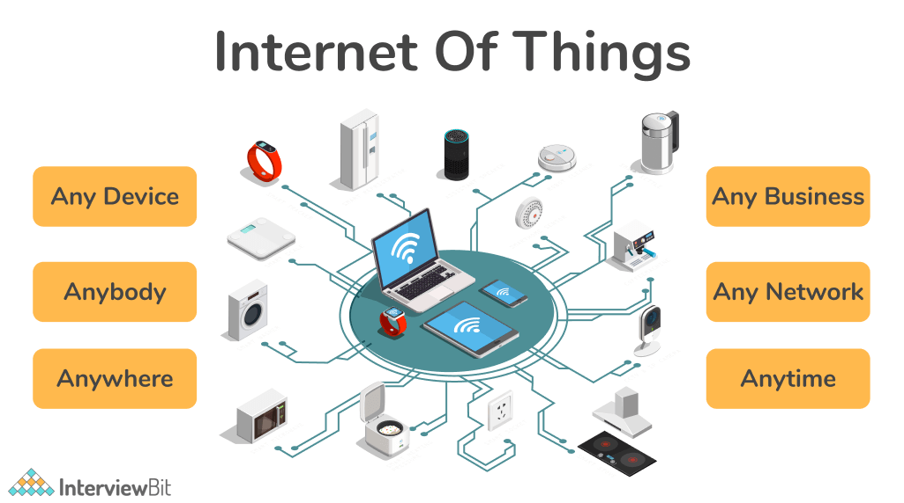

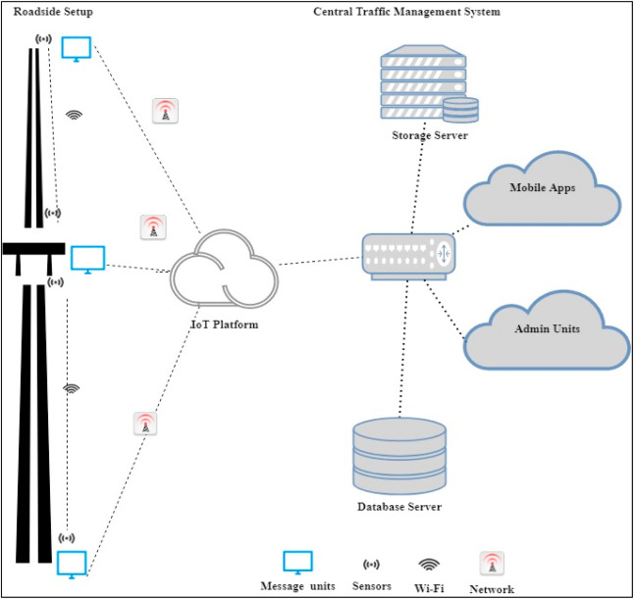

**ADVANTAGES OF IOT AND ARTIFICIAL INTELLIGENCE IN**

**ROAD SAFETY:**

The transportation authority is associated with a high

maintenance cost, fatal accidents, injuries, and loss of life

every year. For a developing nation like India, it is vital to

find a solution. The best way to tackle this problem is with

the help of the booming technologies of today like Machine

Learning and artificial intelligence. These technologies can

help optimize the maintenance cost and prevent fatal

accidents, thus saving the lives of civilians.

Detecting human behavior:

One of the major reasons that contribute to fatal accidents is

human behavior and their negligence to follow the traffic

rules. IoT can play a proactive role in helping drivers adopt

safety rules. With the help of IoT, the traffic management

system gets updated with real-time data, thus increasing the

efficiency of the safety system. With the help of Machine

Learning and IoT, we can judge the driver's behavior and

alert them simultaneously. For example, in [27], a deep

learning model is proposed to explore the complex

interactions between the driver's behavior and the road

environment. The proposed model consists of an

unsupervised Denoising Stacked Autoencoder (SDAE) tha